LOVE SAVVY JEWEL V
© 2021 by Ntumba Mukendi
All rights reserved. Printed in the United States of America. No part of this book may be reproduced or used in any form or by any means—electronic, mechanical, photocopying, recording, or otherwise—without prior written permission from the author, except for brief quotations used in reviews or critical articles.
To purchase or for contact information, please visit:
www.ntumbantumba.net
www.barnesandnoble.com
Fifth Series Edition: March 2025

CONTENTS

Chapter 1 3
Chapter 2 21
Chapter 3 33
Chapter 4 59

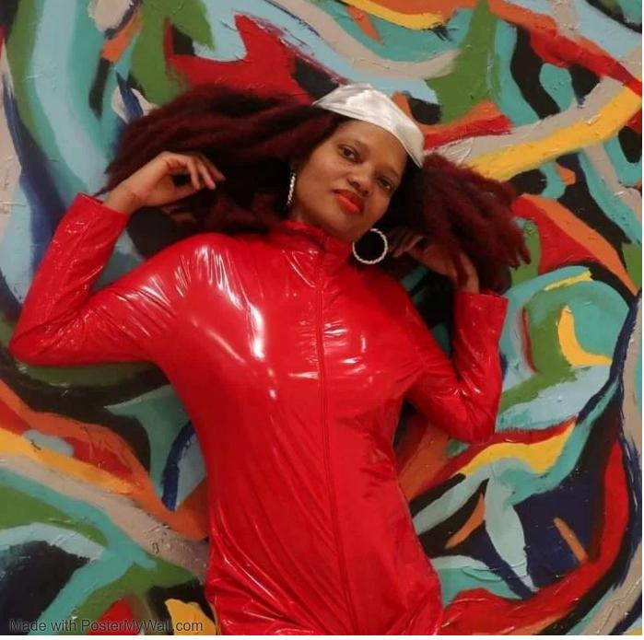Chapter 1
Ntumba
It seemed a little suspicious to me that he was just standing there in his clingy cotton trunks freely, door open, calling me over as he watched me dump the trash in the dumpster outside. Despite the evidence, I thought, We’re neighbors… no big deal.
He profusely apologized for being a no-call, no-show when he was supposed to take me to Trader Joe’s and cook for me. He even insisted on giving me money so I could still go to Trader Joe’s, even if he couldn’t make it. I said, No, no need for all that. Just come to my Zoom book and poetry jam.
He started explaining that he had a new phone that hadn’t been working properly.
“Come in,” he said, inviting me in so he could explain further.
After a quick tour of his place, I somehow ended up sitting on the sofa in the mini living room of his bedroom. I reminded myself: the last tiff I had with him—before we patched things up and became friends—I had made it very clear that I was not attracted to him and not interested.
As I sat there, he started telling me how I was “different,” “clean,” and “not a hoe.” Then he said he would kiss that.
Have you ever seen the sitcom Martin? Do you remember Jerome?
This neighbor is our neighborhood Jerome.
“Look, look,” he said, and then started pulling out his wrinkled ding-a-ling. I walked out of there so fast!
I was so angry that I didn’t even tell him off—but the next time I see him, I am going to tell him off. Ooh, my blood is boiling as I’m writing this right now.
This neighbor is clearly exhibiting an imbalance of masculine and feminine energy.
The truth is, many of us grew up without a healthy example of what balanced masculine and feminine energy looks like in male bodies.
Despite how chaotic or confusing these situations may appear on this earth, on a deeper spiritual level, they’re often part of a bigger picture. Before we were born, we made soul contracts—with soulmates like our fathers, for example—not to punish us, but to help shape us into who we are meant to become to fulfill our divine purpose.

My Love Energy Compass service maps the balance between masculine and feminine energies, helping you navigate the most beneficial path to achieve your goals coupled with legitimate referrals to free entrepreneurial services.
The healthy balance of masculine and feminine energy is Agape love. The moment you experience this balance is the moment when effortless manifestation occurs. This is the moment when realities are born into existence. An example of a collective present-day Love Energy Compass reading can be found in my Soulfood Sunday (5.25.25) YouTube inspiration below:
Soulfood Sunday: Why is love—and all-around manifestation—in the air?
What's up, soulmates! This week, we're having a stronger experience of being one love... or, as Christians would say, one body.
Flashback Friday: I posted the above Soulfood Sunday on May 25, 2025. On Friday, May 30th, Keke Palmer posted a video featuring the song Offscript, which is out now from her upcoming album, Just Keke. Teyana Taylor also posted a video of a song from her forthcoming visual album, Escape Room, which is set to release in August.

Previously...
The hard truth to swallow is that twin flames don’t always end up together in this lifetime. That’s what my Reiki practitioner told me during our session—something I already knew. Often, twin flames come into the same lifetime not to stay together, but to catalyze spiritual growth. After that, they part ways... and sometimes meet a soulmate instead.

Right now, I’m talking to two possible potentials. They’re both good men. One lives a great distance from me and works long hours, so we haven’t spent time together yet. The other is navigating a financial transition. I know what you’re thinking—what’s wrong with just being his friend until he gets back on his feet? My response is: whatever happened to being there when times are hard? Besides, he might see me as a gold digger if I only pursue something romantic once he’s financially stable again.
So, which potential do you think is more likely to work out? Is my Twin Flame still in the picture without me knowing it? My Reiki practitioner had a lot to say about sensing my Twin Flame’s presence in my energy during our last session.
What does it all mean?
I’m spilling the tea in Book V.

I have this fantasy of my future boyfriend holding me by the back of my neck as we walk side by side—or holding me by the waist, all hugged up on my booty real close. That kind of intimacy just feels so good to me.
That’s why what my Reiki practitioner said really shocked me. He scanned my body—through Zoom, mind you—and said he saw a gentleman resting at the back of my neck and at my tailbone. According to him, this gentleman enjoys being in my energy.
I told him, That’s wild—because I think I have a Twin Flame.
We were also a couple in Egypt. He was a King, and I was his Egyptian Queen.
But my Reiki practitioner said, “No—he rescued you from being trafficked. It was forbidden for him to be with you because you were from different classes.”
I responded, “Oh… so he was a King just to me?”
He said, “Just to you.”
We reincarnated together in Greece as well.
“Yes,” he confirmed. “You were in Greece together.”
“But he got shot and killed,” I replied.
“Yes,” he said. “But you couldn’t do anything about it.”
“No,” I whispered. “I couldn’t help him. I tried.”
I admitted I’ve been carrying a sense of guilt or responsibility.
He responded, “He took the bullet to save your life. It was a soul choice. There’s nothing to feel guilty about.”
Then he added, “You were together in a recent lifetime.”
“What???” I asked, stunned. “In this lifetime?”
“No. But… does New Orleans mean anything to you?”
“OMG,” I said. “I’ve always wanted to go to New Orleans.”
“What about the Bayou? Does that mean anything to you?”
“OMG,” I repeated. “I’ve always wanted to go to the Bayou. That’s why I love movies like Eve’s Bayou and Jason’s Lyric,” I thought to myself.
He explained, “He was trying to get to you in New Orleans. Each time he followed you to where you were, he would just miss you. You had gone through something… and overcame. He was trying to save you. What you went through made you the woman you are today.”
I was going through a spiritual awakening, and the high-frequency energy was triggering symptoms along the path of my seven chakras. When the energy reached my crown, I’d experience dizzy spells—and sometimes even feel like I was losing parts of my brain function.
My Reiki practitioner told me that my Twin Flame was causing some of these symptoms and asked if I wanted him to be cleared out of my energy.
What?! I thought.
What if we don’t end up together because this Reiki practitioner removes him?
Should I really leave my Twin Flame in my energy—at the expense of my health?
I’ll let you guys know what I decided to do... in Book VI.

